

SERVER

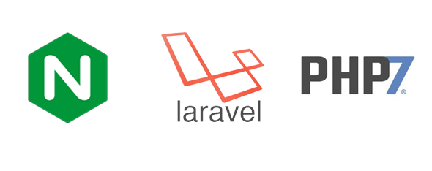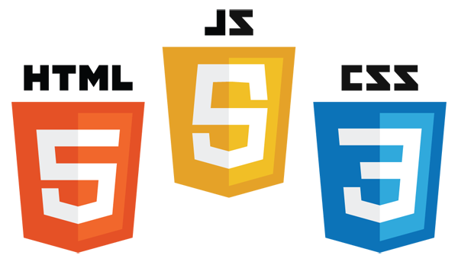

BACK END

UI COMPONENTS

FRONT END

PRESENTATION LAYER

DATABASE LAYER

UI COMPONENTS

The system architecture provides an overview of the system created using a number of different architectural views to depict the processes of the system. For the system’s Front End, it comprises of HTML5, JavaScript, CSS 3. Including the system used bootstrap as a framework for the presentation layer. For the Back end, the technologies used are PHP 7, JSP, Node.js, JavaScript and Laravel for the framework of PHP 7. The database used is MySQL Workbench.